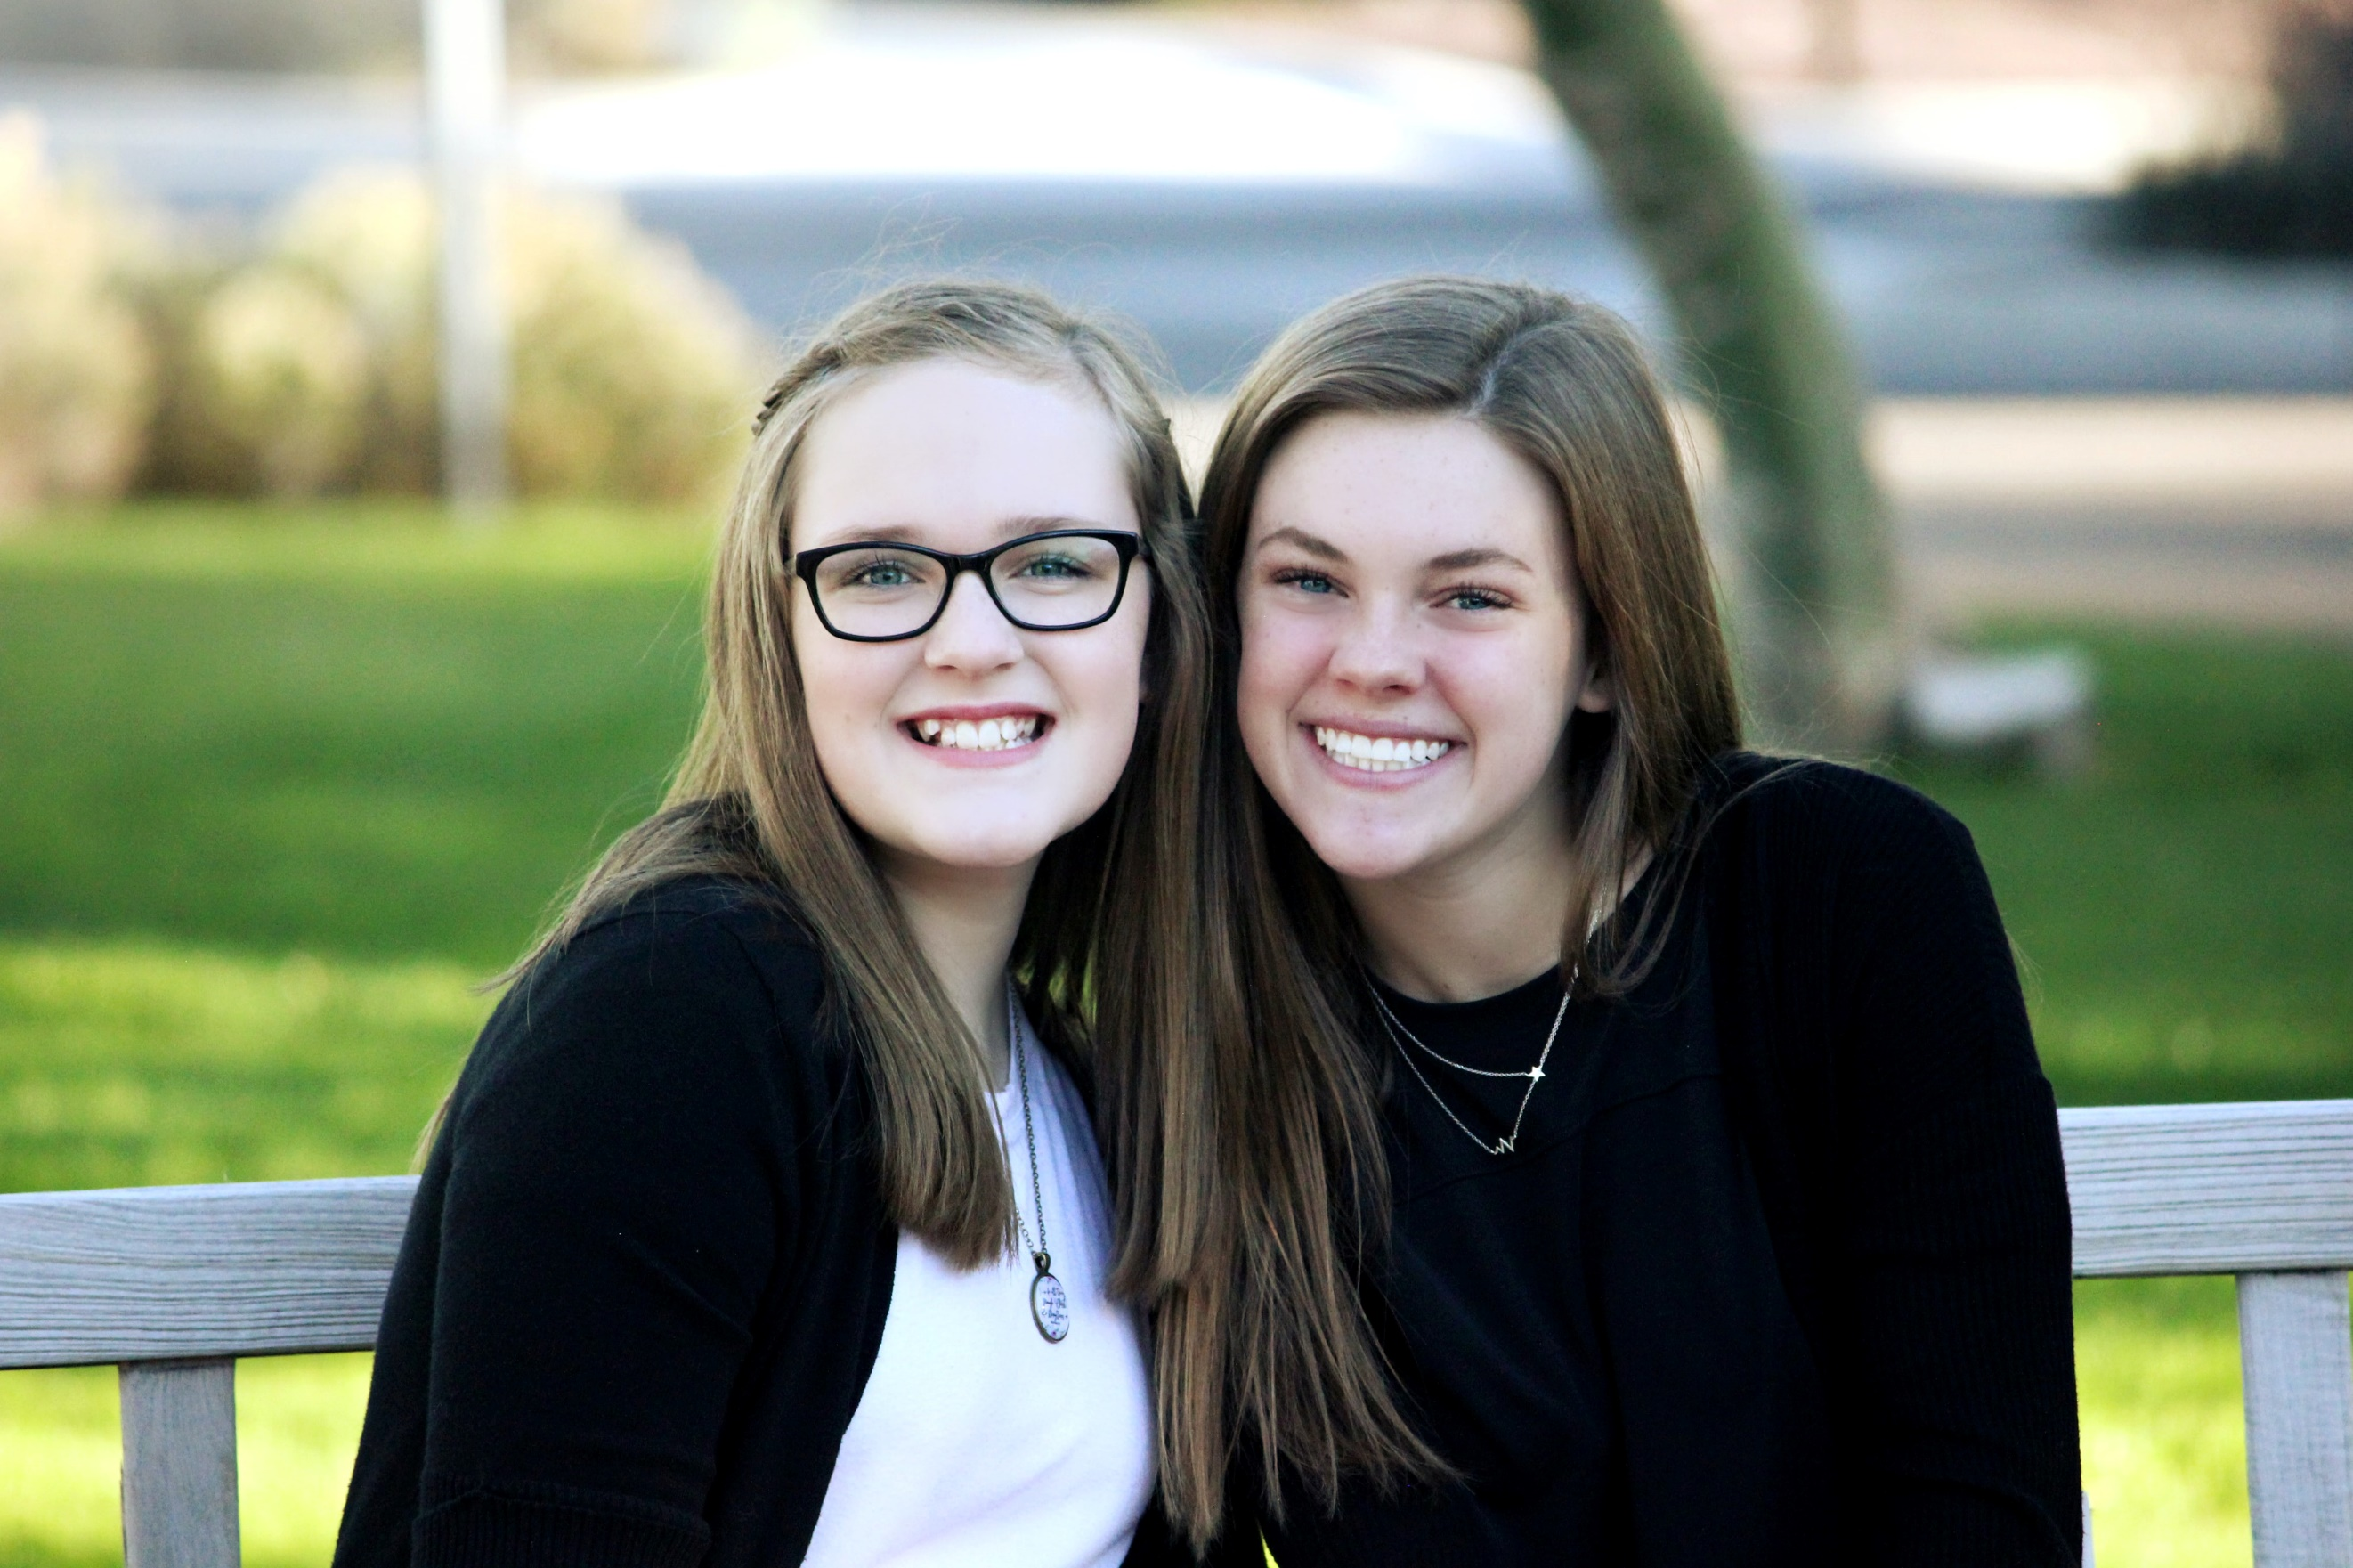
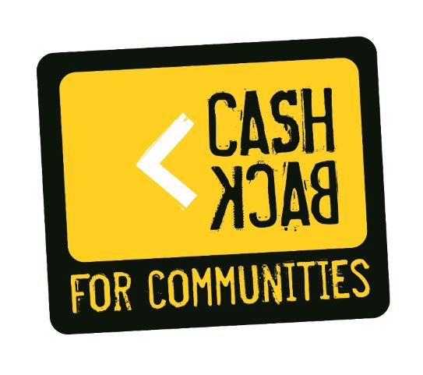
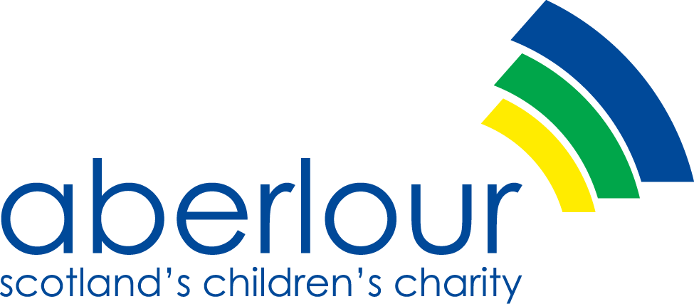
Aberlour Alternative Routes #Cashback
Children’s Rights and Wellbeing Impact Assessment

December 2023

“Underpinning everything we do is our ambition to ensure the children we work with have an equal chance regardless of their start in life. We will work relentlessly to ensure that the United Nations Convention on the Rights of the Child is fully embedded in law and is visible across our organisation and obvious in what we do and how we work with children, young people and their families.”

Being Brave: For Children, Young People & Families – Aberlour Strategy 2021 – 25

Children’s Rights and Wellbeing Impact Assessment
Aberlour Statement of Purpose

Aberlour is committed to supporting, promoting and protecting the human rights of all children and young people. We have championed the incorporation of the United Nations Convention of the Rights of the Child (UNCRC) in order to make the rights of children and young people across Scotland real – for every child, every day, everywhere.
Children and young people’s rights are at the heart of the work we do every day as an organisation, supporting children, young people and families. We will ensure that the voices and views of children and young people will be listened to and acted upon and will inform and influence all decisions that impact upon them and the work we do as an organisation.
We will ensure there is clear accountability and transparency in how we support, promote and protect the rights of children and young people in Aberlour. We will do this consistently through CRWIAs to support the development and delivery of our services, projects and policies to ensure children and young people’s rights remain the primary focus of all our work.

CRWIA Overview and Aims

CRWIAs encourage you to think about how different groups may be affected by a specific policy or piece of work, ensuring consideration and acknowledgement of how it may impact differently on different children and young people. This helps to proactively plan, rather than react, to different circumstances if they arise. CRWIAs are also important for helping to consider any negative impact on children and young people’s rights a policy or piece of work may have. Aberlour is committed to the development and implementation of CRWIAs as part of our work in supporting, promoting and protecting the rights of children and young people. We will also use CRWIAs to help effectively ensure the work we do with partners, including local authorities and public bodies, meets our obligations in relation to UNCRC.

Which children and young people does this CRWIA affect?

All children who access an Aberlour service will be affected by the CRWIA as a national organisation each service may have additional articles to support the range of work they do. Below are the articles identified by Aberlour and the supporting articles for Alternative Routes #Cashback.

How were children and young people involved in this CRWIA?

Aberlour firmly believe Children and young people must be included in the development of CRWIA and should be supported to participate and inform the development of CRWIA in ways that best suit them and meet their needs.
Alternative Routes #Cashback engaged with children and young people on a 1-1 basis and within groups in a school setting to obtain their thought & views.

Scottish Government Training and Guidance

All Alternative Routes #Cashback staff complete the Scottish Government UNCRC training tool and follow Scottish Government and Aberlour guidance –

https://www.gov.scot/publications/childrens-rights-wellbeing-impact-assessments-crwia-training-tool/

https://www.gov.scot/publications/childrens-rights-wellbeing-impact-assessment-guidance/

How will this policy impact on children’s rights?

The CRWIA ensures that in everything we do Aberlour respect and promote children's rights as outlined in the UNCRC. This includes the right to leisure, play, education, cultural participation, and non-discrimination.

Monitoring/Review

The CRWIA for Alternative Routes #Cashback will be monitored and reviewed at least annually.

The Articles below have been identified by Aberlour.

Article 2
All children have these rights no matter what.
Article 3
Everyone who works with children should always do what is best for each child.
Article 12
Your right to be listened to and taken seriously.
Article 18
You have the right to be brought up by both parents if possible.
Article 20
You have the right to special protection & help if you can’t live with your own family.
Article 22
If you are a refugee, you have the same rights as children born in the country.
Article23
If you have a disability, you have the right to special care and education.
Article 27
You have the right to have a proper house, food & clothing.
Article 31
You have the right to relax & play.
Article 39
You have the right to help if you have been hurt, neglected, or badly treated.

In addition to the above, the Alternative Routes #Cashback team has identified the following articles to support their work.

Article 6
You should be supported to live & grow.
Article 8
You have the right to an identity.
Article 12
Your right to be listened to & taken seriously.
Article 19
You have the right to be protected from being hurt or badly treated.
Article 29
You have the right to an education which develops your personality respect for others’ rights & the environment.
Article 31
You have the right to relax and play.
Article 34
Nobody should touch you in a way that makes you feel uncomfortable, unsafe, or sad.
Article 40
You have the right to legal help & to be treated fairly if you have been accused of breaking the law.

The Children and Young People (Scotland) Act 2014 is about improving the wellbeing of children in Scotland. The Act is wide ranging and includes key parts of the national practice model Getting it Right for Every Child, commonly known as GIRFEC.

The eight wellbeing indicators known as SHANARRI help ensure everyone who supports a child is working to the same outcomes and have a common understanding of wellbeing.

SHANARRI - Safe, Healthy, Achieving, Nurtured, Active, Respected, Responsible and Included.

How UNCRC and children’s rights will inform the work of Alternative Routes #Cashback

Article 6 You have the right to life and to grow up to be healthy.

Having the highest attainable standards of physical and mental health, access to suitable healthcare and support in learning to make healthy, safe choices.
SHANARRI indicator - HEALTHY

Individual plans are created with each child to ensure a person-centred approach is taken to support their development.

Individual support in relation to attending health related appointments, information re healthy eating, healthy choices and opportunities to take part in activities which promote health.

Article 8 You have the right to an identity.

Having the opportunity, along with carers, to be heard and involved in decisions that affect them. SHANARRI indicator – RESPECTED

Having help to overcome social, inequalities, and being accepted as part of the community in which they live and learn community.
SHANARRI indicator - INCLUDED

We will respect your right to a name, nationality & family ties.
We will recognise you are an individual and have a right to be who you want to be.
We will always treat you with respect & dignity.

Article 12 Your right to be listened to & taken seriously.

Having the opportunity, along with carers, to be heard and involved in decisions that affect them. SHANARRI indicator – RESPECTED

Having help to overcome social, inequalities, and being accepted as part of the community in which they live and learn community.
SHANARRI indicator - INCLUDED

Every child has the right to express their views, feelings and wishes in all matters affecting them, and to have their views considered and taken seriously. This right always applies, for example during immigration proceedings, housing decisions or the child’s day-to-day home life.

Article 19 You have the right to be protected from being hurt or badly treated.

Protected from abuse, neglect, or harm at home, at school and in the community.
SHANARRI indicator - SAFE.

Your right not be harmed and to be looked after and kept safe. Aberlour has a dedicated Safeguarding officer responsible for supporting staff and overseeing the organisational safeguarding team. All staff members are trained in child & adult protection procedures. Aberlour has robust polices & procedures that are designed to keep you safe.
We will always advocate on your behalf to protect you from violence, abuse & neglect from adults.

Article 29 You have the right to an education which develops your personality respect for others’ rights & the environment.

Being supported and guided in learning and in the development of skills, confidence, and self-esteem, at home, in school and in the community.
SHANARRI indicator - ACHIEVING.

You have the right to an education which develops your personality respect for others’ rights & the environment.

Alternative Routes delivers support in schools and the local community. We will work with others to ensure you have the opportunity to develop as an individual and your interests and talents are nurtured to encourage you to grow and develop in all areas.

Article 31 You have the right to relax and play.

Having opportunities to take part in activities such as play, recreation and sport, which contribute to healthy growth and development, at home, in school and in the community.
SHANARRI indicator - ACTIVE

We will provide opportunities for activities, ensuring you are involved in the planning. We will offer support to help you grow in confidence and encourage your participation in play & leisure activities. We will aim to ensure a safe, stimulating and stress-free environment.

We will help you make positive connections at school and in your community.

Article 34 (Nobody should touch you in a way that makes you feel uncomfortable, unsafe, or sad.)

Protected from abuse, neglect, or harm at home, at school and in the community.
SHANARRI indicator - SAFE.

We will always advocate on your behalf to protect you from violence, abuse & neglect from adults.
Aberlour has a dedicated Safeguarding officer responsible for supporting staff and overseeing the organisational safeguarding team. All staff members are trained in child & adult protection procedures. Aberlour has robust polices & procedures that are designed to keep you safe.

We will work to ensure you are protected from physical, sexual or emotional harm, abuse or exploitation.

Article 40

You have the right to legal help & to be treated fairly if you have been accused of breaking the law.
Having help to overcome social, inequalities, and being accepted as part of the community in which they live and learn community.
SHANARRI indicator - INCLUDED

We will support you to access legal advice.

We will provide emotional & practical support, and ensure you are treated fairly, listened to and included in all aspects of support.

David Barr | Amanda McAllister
Assistant Director Operations | Service Manager
15th December 2023 | 15th December 2023

